Circuit Analysis Lab #6

Verification of Kirchhoff’s Laws
Name: Noor Fatima
Registration No: 2025CE77
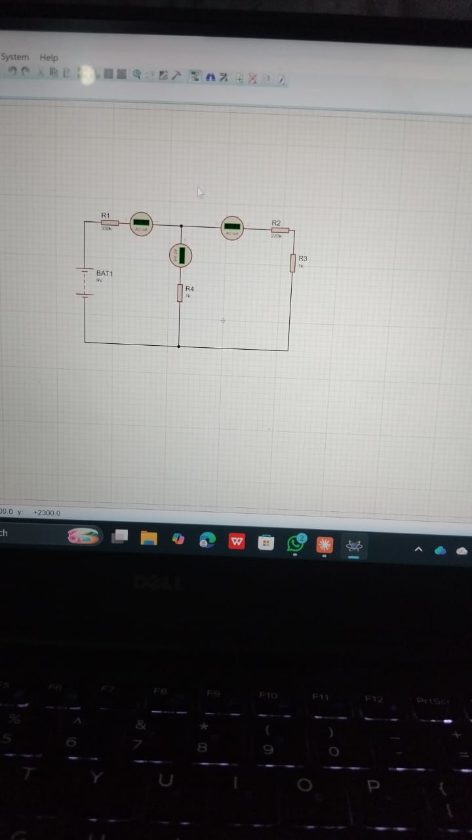
KCL Practical Values
Sl. No | Voltage (V) | I1 (mA) | I2 (mA) | I3 (mA) | Check
1 | 5 | 15 | 7 | 8 | ✔
2 | 15 | 45 | 20 | 25 | ✔
3 | 25 | 75 | 35 | 40 | ✔

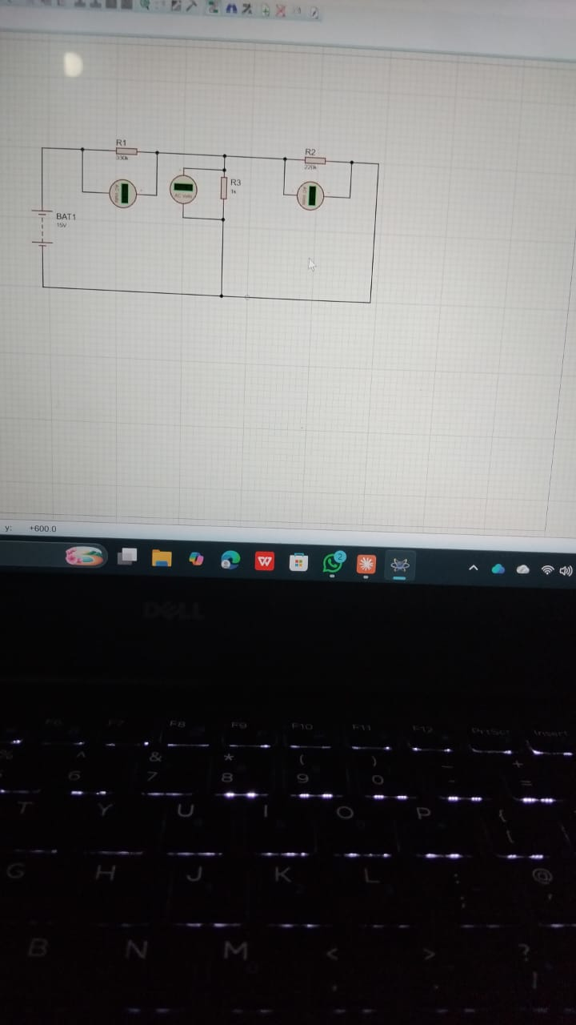
KVL Practical Values

Sl. No | E1 (V) | V1 (V) | V2 (V) | V3 (V) | Check
1 | 5 | 2 | 1.5 | 1.5 | ✔
2 | 10 | 4 | 3 | 3 | ✔
3 | 15 | 6 | 4.5 | 4.5 | ✔
Result:
Kirchhoff’s Current Law and Voltage Law are verified successfully.

Post Lab Questions
- Kirchhoff’s Current Law (KCL): The sum of currents entering a node equals the sum leaving it.
- Kirchhoff’s Voltage Law (KVL): The sum of voltages in a closed loop equals zero.
- Applications: Used in electronics, labs, power supplies, and control systems.
- Limitations: Not ideal for high-frequency or distributed systems.

